AWS Task-3

Task Description:

- Create a S3 bucket, with no public access and upload files to the bucket & view the logs using cloudwatch for the uploaded files.

Step 1: Creating a bucket
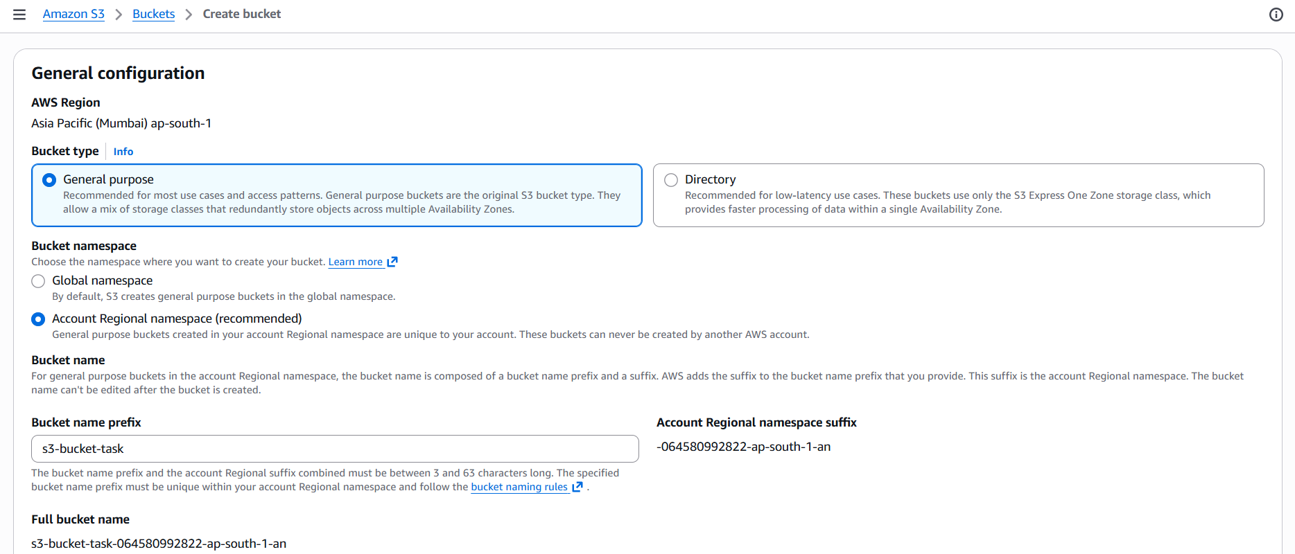

All public access has been blocked while creating the bucket

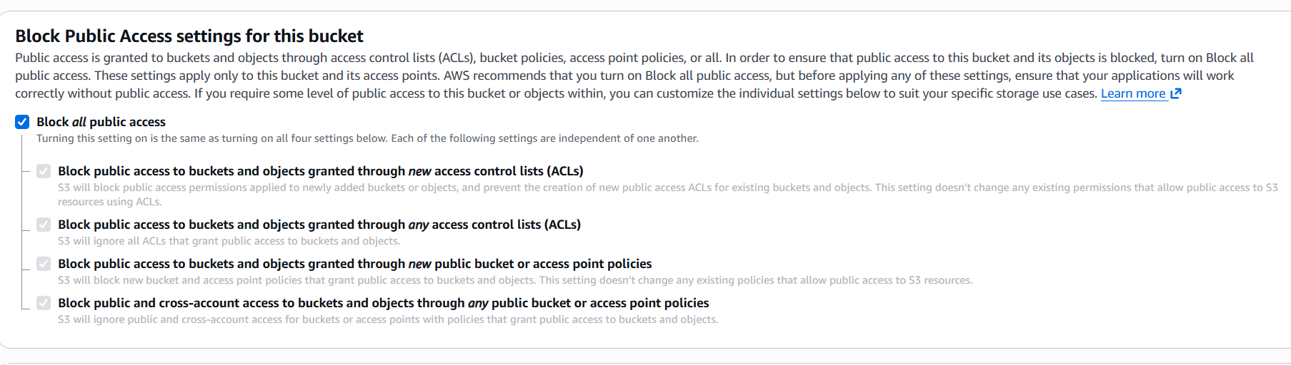
Step 2: Uploaded a file
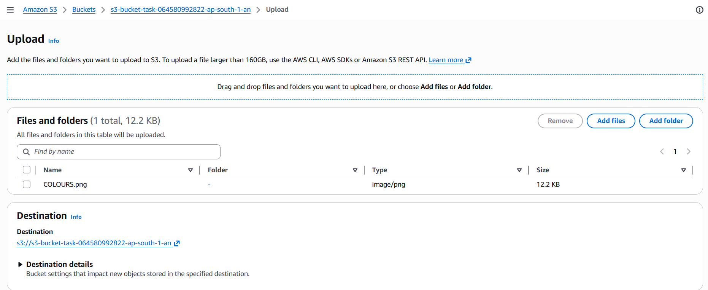

Copied URL shows access denied instead of showing the file.

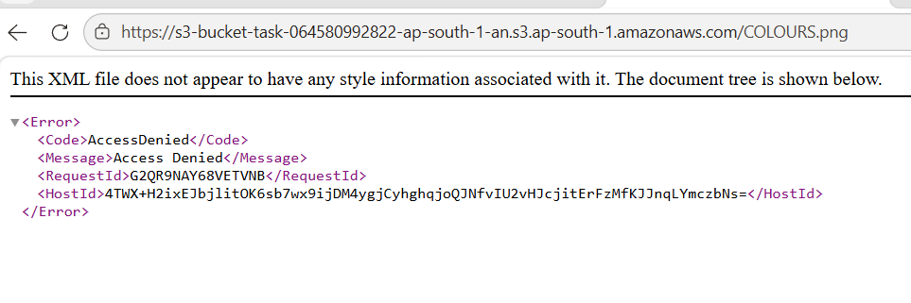

Step 3: Edit the permission of the bucket created.
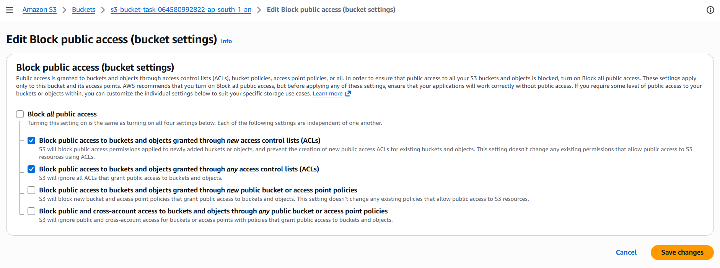

Step 4: Edit bucket policy
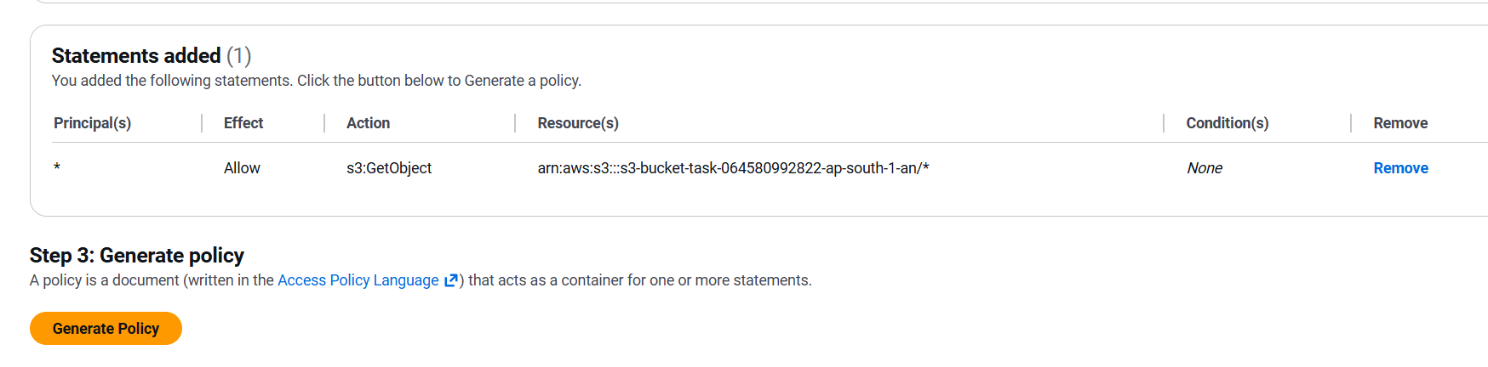

Pasted the policy created
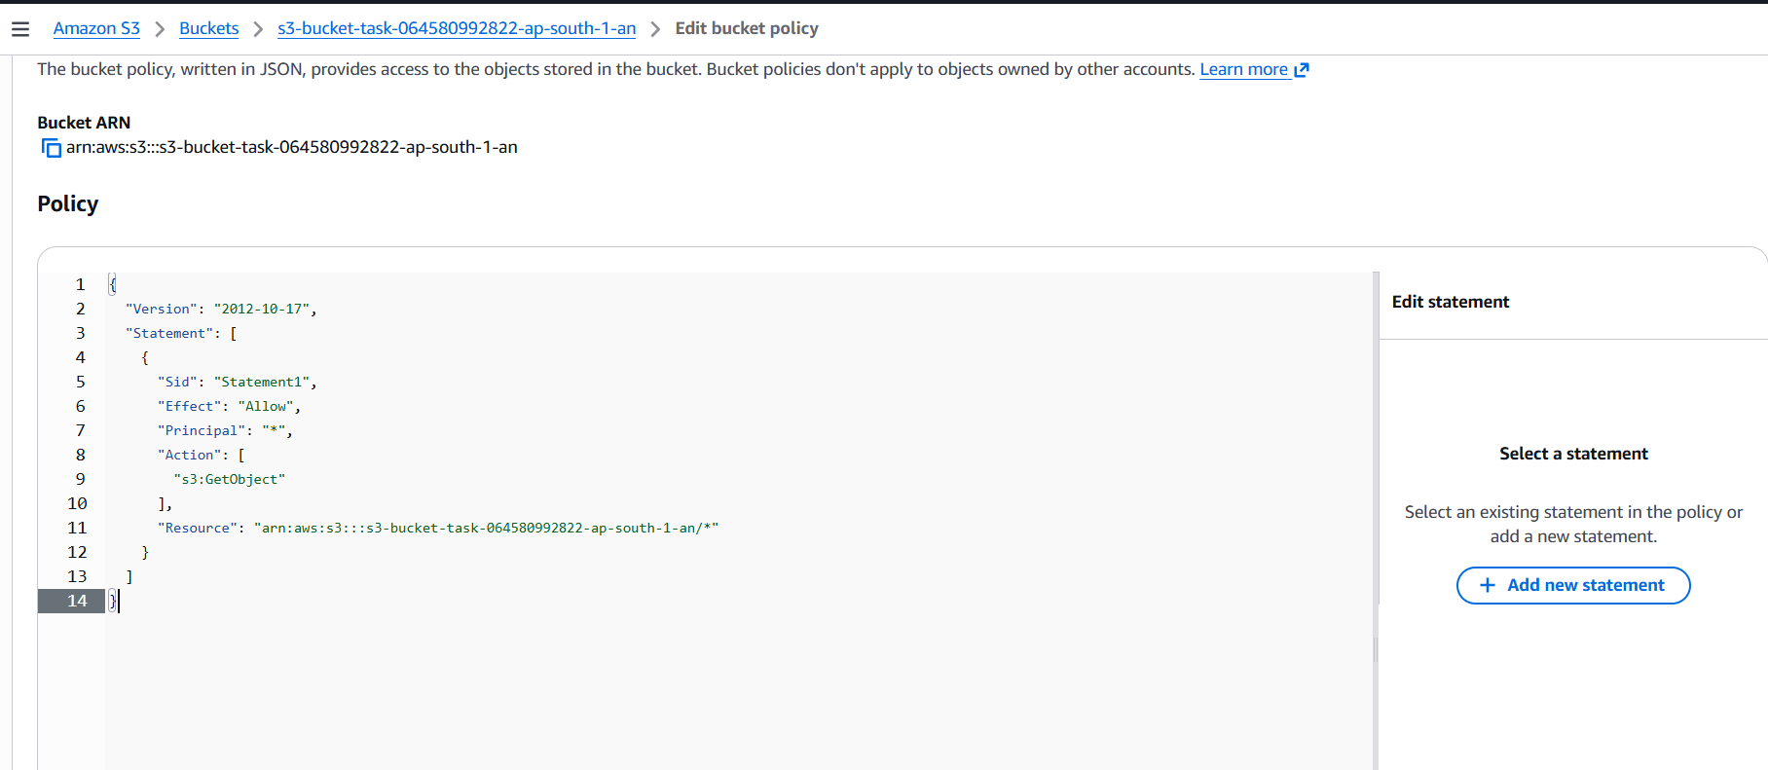

Copied URL shows up the content



- Launch two ec2-instances and connect it to a application load balancer, where the output traffic from the server must be an load balancer IP address

Step1: Creating two instances with same configuration by selecting Allow HTTP traffic from the internet and entering the below code as well

#!/bin/bash
# Use this for your user data (script from top to bottom)
# install httpd (Linux 2 version)
yum update -y
yum install -y httpd
systemctl start httpd
systemctl enable httpd
echo "<h1>Hello World from $(hostname -f)</h1>" > /var/www/html/index.html

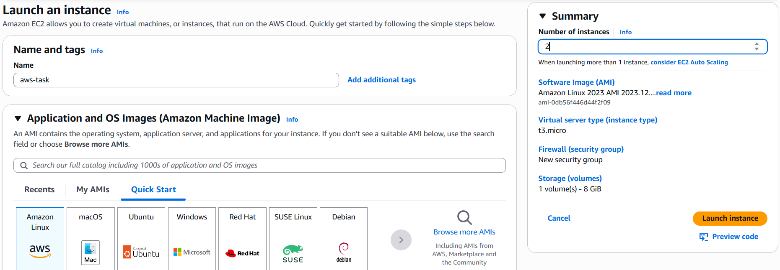

Step2:

Instance 1 aws-task1 public IP result
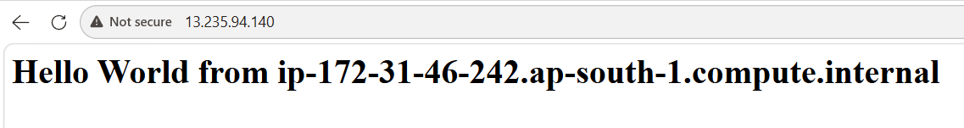
Instance 2 aws-task2 public IP result
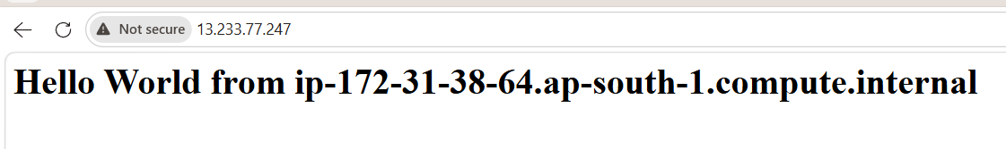

Step 3:
Create a application load balancer (ALB)

Name: asw-task-lb
Scheme: Internet facing
Availability zone : ap-south-1a and ap-south-1b
Create security group by allowing HTTP traffic and select it
Create Target group and select it

Load balancer created by selecting our two instances in target group.

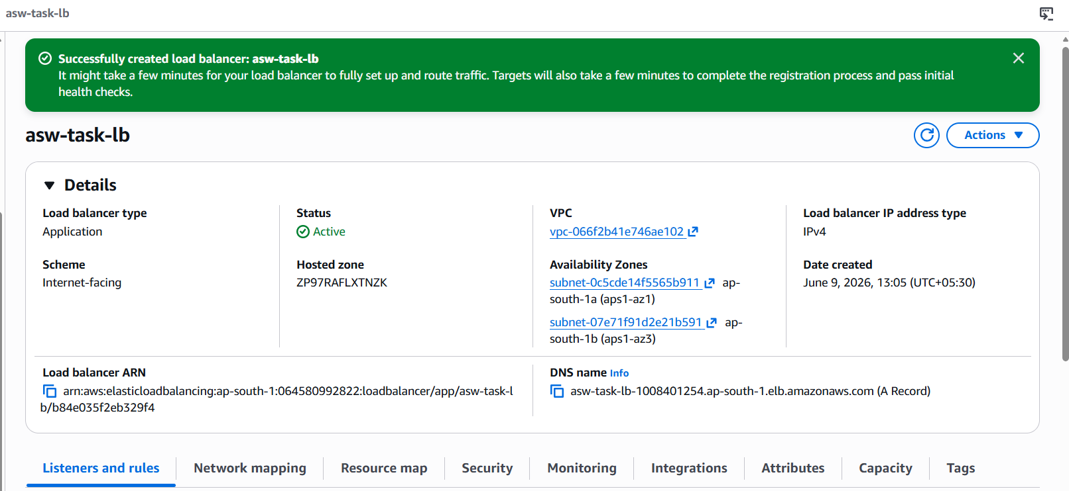

Step 4:
Copied loadbalancer DNS and pasted

